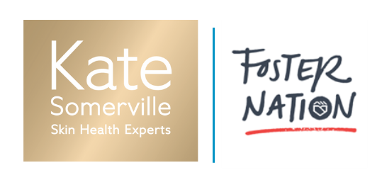

KATE SOMERVILLE + FOSTER NATION
“DEFY IMPOSSIBLE” SCHOLARSHIP

Scholarship Description & Award Information

Kate Somerville Skin Health Experts is committed to supporting Californian foster youth as they age out of the system-- providing resources, professional training, and mentorship to help make their dreams possible.

Having grown up in a home impacted by addiction, brand founder Kate knows firsthand the challenges young people face when one or both parents are unable to care for their family. As a teen, Kate left home, moving in with friends and sleeping on couches as she tried to find her way in the world. Kate’s life changed when she found a mentor who gave her unconditional love and support. She also taught her the value of believing in yourself. Kate knows how hard it is to find your place in the world without the security of family. She knows the power of having a helping hand and support at that critical age and personifies what’s possible when young adults have someone to believe in them. She recognizes the transformative power a career in the beauty industry had on her life - and is passionate about leveraging her platform to positively impact the lives of foster youth aging out of the system so they can pursue their dreams and make the impossible - possible.

Kate Somerville Skin Health Experts is partnering with Foster Nation to support foster youth as they age out of the system -- providing resources, professional training, and mentorship. As part of this partnership, the Kate Somerville + Foster Nation “Defy Impossible” Esthetics scholarship supports professional beauty career paths for foster youth. This scholarship is open to individuals aging out, or who have already aged out, of the foster care system and who are new or currently enrolled in an esthetics program at a recognized school. In addition to funding this scholarship, there may be opportunities for training at a Kate Somerville Skin Health Experts Clinic with a licensed skin therapist.

Scholarship Name: Kate Somerville + Foster Nation “Defy Impossible” Esthetics Student Scholarship

Award Amount | # of Recipients: $15,000 each x 2 Recipients (total)
(2) for Summer 2022, open from June 1 – August 31, 2022

Applicant Qualifications:
- The applicants must have spent any length of time in the foster care system before the age of 18 in the state of California.
- Must plan to enroll in an esthetics program at a licensed training school or program that leads to licensure.
- Must maintain at least an 85% GPA, 90% attendance record with no-show/no-call days on record through duration of program.
- Must be a United States Citizen living in California.
Application Requirements:

- Complete online application.
- Upload proof of time spent in foster care – either a Ward of Court letter from the California Ombudsmen Office, or from your social worker.
- Submit a three to five-minute maximum, YouTube video with a public link answering the following questions:

- Kate Somerville’s purpose is to heal skin and transform lives by making the impossible possible. We champion those who relentlessly chase their dreams. What challenges have you overcome and how have you relentlessly chased your dreams?
- How will a career in beauty help you achieve those dreams?
- Why is esthetics your passion? How has your experience with your skin shaped this passion?

